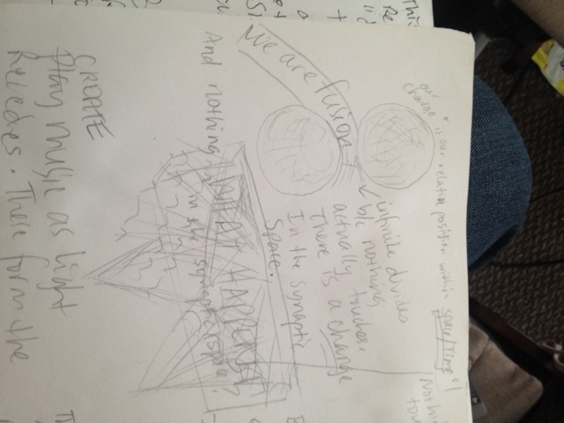Nothing touches due to synaptic space.

Infinite amounts of small sparks (charges).

But, on this system, is the equation perfectly balanced? No. It’s par amount balanced teeter totter in every infinite direction of possibility .

This makes it “seemingly wobble”

Reminds you of:

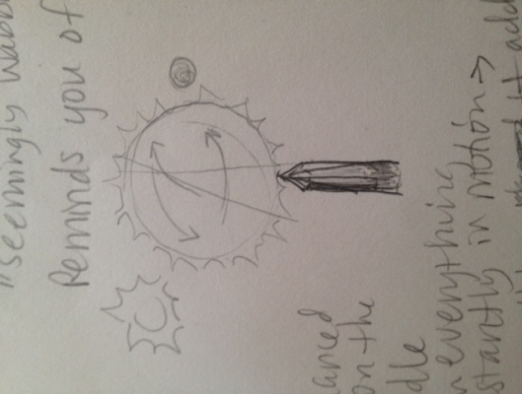

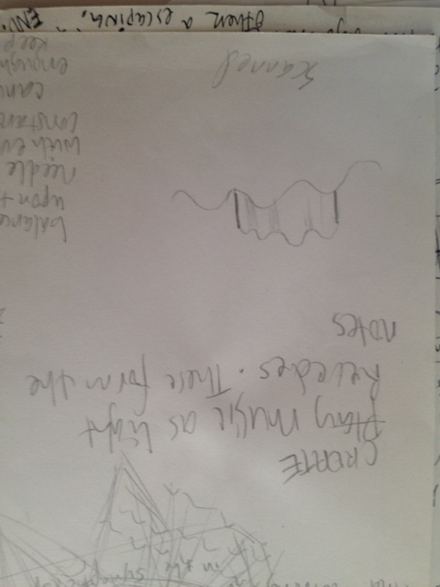balanced upon the needle with everything constantly in motion 🡪 cancelling and adding enough focused energy to keep it there, but only almost perfect.